UDC

TITLE OF THE ARTICLE
Name Surname¹, Name Surname²
¹Institution, Country, City
²Institution, Country, City
e-mail: contact person

Abstract: Text, text, text.
Keywords: word, word, word.

Introduction

Text, text, text.
Text, text, text.

Materials and Methods

Text, text, text.
Text, text, text. (1).

$x_{ij}^{norm}=\frac{x_{ij}}{\begin{matrix}max & x_{ij} \\ j & \end{matrix}} (1)$,
where $x_{ij}^{norm}$ – a normalize value of j- indicator that i-region-subject possess , $\begin{matrix}max & x_{ij} \\ j & \end{matrix}$ – a maximal value of j-indicator among the RF studied regions.

Text, text, text.
Text, text, text. [1].

Results and Discussion

Text, text, text. (tab. 1)
Text, text, text.
.

Table 1 – Parameters of the agricultural settlement dynamics in the Orenburg-Kazakhstan frontier region
Parameter | Year of census | Buffer zones |  |  |  | Region on the whole
 |  | 5 km | 10 km | 20 km | 50 km
A part of rural population (%) | 1989 | 3,6 | 6,2 | 12,5 | 33,6 | 100
 | 2002 | 3,7 | 6,3 | 12,4 | 32,0 | 100
 | 2010 | 3,4 | 5,9 | 11,6 | 32,7 | 100
A part of rural settlements (%) | 1989 | 3,1 | 5,8 | 10,5 | 28,7 | 100
 | 2002 | 3,1 | 5,7 | 10,4 | 28,6 | 100
 | 2010 | 3,2 | 5,6 | 10,4 | 29,3 | 100
An average population number in a rural settlement (persons) | 1989 | 602 | 553 | 618 | 606 | 518
 | 2002 | 641 | 595 | 643 | 607 | 542
 | 2010 | 543 | 518 | 554 | 556 | 497
A density of rural population (person/km²) | 1989 | 4,3 | 4,0 | 4,4 | 5,3 | 7,3
 | 2002 | 4,5 | 4,2 | 4,5 | 5,2 | 7,5
 | 2010 | 3,7 | 3,4 | 3,7 | 4,7 | 6,6

Text, text, text [2].
Text, text, text (fig. 1).

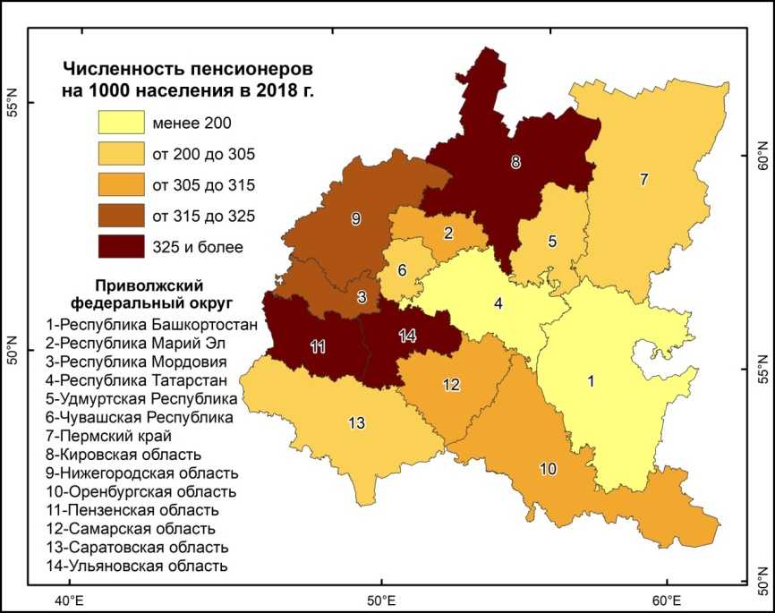
Figure 1 – A number of retirees in the regions of the Privolzhskiy Federal district per 1000 persons of the constant population in 2018.

Text, text, text.

Conclusion

Text, text, text.

Acknowledgments

Text, text, text (reference to a state task or grant in the frame of which the study is conducted).

References

1. An example of References template is below.

Conflict interests: The author declares that there are no obvious and potential conflicts of interest associated with the publication of this article.

ARTICLE TITLE
N. Surname¹, N. Surname²
¹ Affiliation, Country, City
² Affiliation, Country, City
e-mail: contact person

Abstract: Text, text, text.
Key words: word, word, word.

References

1. References (transliteration, BSI variant; transliteration is not required for references in the English language). The text can be transliterated online: http://translit.net/ru/?account=bsi

Information about authors:

Name, Last mane, Surname (in the Russian language)
Academic degree, position, affiliation.
ORCID
Name, Surname (in the English language)
Academic degree, position, affiliation (in the English language)

ПРИМЕРЫ ОФОРМЛЕНИЯ СПИСКА ЛИТЕРАТУРЫ и REFERENCES:

Описание книг:
на русском
Бакланов П.Я. Территориальные структуры хозяйства в региональном управлении. М.: Наука, 2007. 239 с.
транслитерация
Baklanov P.Ya. Territorial'nye struktury khozyaistva v regional'nom upravlenii. M.: Nauka, 2007. 239 s.

Описание статьи из журнала:
на русском
Ефимова Т.Н., Кусакин А.В. Охрана и рациональное использование болот в Республике Марий Эл // Проблемы региональной экологии. 2007. № 1. С. 80-86.
транслитерация
Efimova T.N., Kusakin A.V. Okhrana i ratsional'noe ispol'zovanie bolot v Respublike Marii El. Problemy regional'noi ekologii. 2007. N 1. S. 80-86.

Описание статьи из журнала c DOI:
на русском
Чибилёв А.А. (мл.), Чибилёв А.А. Современное состояние и проблемы модернизации природно-экологического каркаса регионов степной зоны Европейской России // Юг России: экология, развитие. 2019. Т. 14, № 1. C. 117-125. DOI:10.18470/1992-1098-2019-1-117-125.
транслитерация
Chibilev A.A. (ml.), Chibilev A.A. Sovremennoe sostoyanie i problemy modernizatsii prirodno-ekologicheskogo karkasa regionov stepnoi zony Evropeiskoi Rossii. Yug Rossii: ekologiya, razvitie. 2019. T. 14, N 1. C. 117-125. DOI:10.18470/1992-1098-2019-1-117-125.

Описание материалов конференций:
на русском
Марьинских Д.М. Разработка ландшафтного плана как необходимое условие устойчивого развития города // Экология ландшафта и планирование землепользования: тезис. докл. Всерос. конф. Новосибирск, 2000. С. 125-128.
транслитерация
Mar'inskikh D.M. Razrabotka landshaftnogo plana kak neobkhodimoe uslovie ustoichivogo razvitiya goroda. Ekologiya landshafta i planirovanie zemlepol'zovaniya: tezis. dokl. Vseros. konf. Novosibirsk, 2000. S. 125-128.

Описание Интернет-ресурса:
на русском
Министерство природных ресурсов и охраны окружающей среды Ставропольского края, 2017. URL: http://www.mpr26.ru/ministerstvo/informatsiya/news/chto-nesut-nam-reki.html (дата обращения: 20.01.2020).
транслитерация
Ministerstvo prirodnykh resursov i okhrany okruzhayushchei sredy Stavropol'skogo kraya. URL: http://www.mpr26.ru/ministerstvo/informatsiya/news/chto-nesut-nam-reki.html (data obrashcheniya: 20.01.2020).

Books:
in English
Salomonson,V., Appel, I. Estimating fractional snow cover from MODIS using the normalized difference snow index. Remote Sens. Environ., 2004, 89, 351-360.

Articles:
in English
Chibilev A.A., Petrishchev V.P., Levykin S.V., Kazachkov G.V., Ashikkaliev A.K. The soil-ecological index as an integral indicator for the optimization of the land-use structure. Geography and Natural Resources. 2016. vol. 37. no. 4. pp. 348-354.

Materials of a conference:
in English
Sz. Gőri, I. Kapocsi, Cs. Aradi Restoration of natural hydrological systems in the Hortobágy National Park. In: III. International meeting on hydrological restoration of wetlands, Huelva, October 19-22. 2004. 2005. Proceedings 96-112 pp.

Electronic resource:
in English
Fan, X., Liu, Y., Tao, J., Weng, Y. Soil Salinity Retrieval from Advanced Multi-Spectral Sensor with Partial Least Square Regression. Remote Sens. 2015, 7(1), 488-511. Available online: http://www.mdpi.com/2072-4292/7/1/488/htm.

